Ramapo College Of New Jersey

**Senior Project**

**CMPS 450**

Spring 2019

School of Theoretical And Applied Sciences

Cubaminoes: A Human vs Computer Android dominoes game

**Author:**

Ashish Ghimire

**Submitted To:**

Professor Victor Miller

**1. INTRODUCTION**

For my senior project class, I designed a Human vs Computer two-player Android dominoes game called Cubominoes. Cubaminoes is a blend of the words, Cuban and dominoes. The game is based on a popular dominoes game that Cubans play during social gatherings.

**a) Project objectives**

The primary objective of my project was to design a strategic Android game that can be played primarily for recreation purposes. Although Cubmanoes is not a multiplayer human vs human game, it has the potential to be one. If it develops to be a multiplayer game in the future, it can be played in social gatherings in the same way dominoes games are played in Cuba and other Latin American countries.

Another objective was to design a game where the human player plays against the computer player that tries its best to make optimal moves to defeat the player. This may make the game more challenging and more rewarding to play.

**b) Basic Game Description : How the game works**

At the start of a new tournament (game), the human player is asked to set a threshold tournament score. The tournament will be over when either player reaches or surprasses the tournament threshold score or until the human player wants to play. The human player can save the game at any time. The human player can also exit the game by pressing the exit button in the main game page (look at section 3: User’s manual, to learn more about the exit button) at any time.

A tournament will be comprised of one or more rounds. In each round, the players should aim to have a better score than their opponent. The game will consist a set of 28 tiles (dominoes) where each tile will be composed of two stones where each stone will be have a value from 0-6. For instance, 5-4 is a string representation of a tile composed of stone 5 and stone 4. The string representation of all the tiles the game uses is listed below:

6-6, 5-5, 5-6, 4-4, 4-5, 4-6, 3-3, 3-4, 3-5, 3-6, 2-2, 2-3, 2-4, 2-5, 2-6, 1-1, 1-2, 1-3, 1-4, 1-5, 1-6, 0-0, 0-1, 0-2, 0-3, 0-4, 0-5, 0-6.

A pictorial representation of a tile (domino) would look like this in the game:

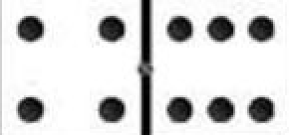Fig: A tile (domino) whose left stone is 4 and right stone is 6

The game set (stock) will be shuffled at the start of each round and each players will be distributed 8 tiles. Remaining tiles form a stock that is kept on the table. Each round will have an engine, the first tile to be played in the round.

In the first round, the engine will be 6-6, in second round 5-5 and so on. The engine tile will be clearly displayed on the top right hand corner of the main game screen and in the center of the table (see section 3). The player with the engine starts the round by putting the engine on the table. At the start of each round, the human player will be prompted to do perform one or more of the two options:

* If no player has the engine tile in their hand, the human player will be asked to press the button labeled “Draw Tiles.” Doing so will add 1 tile each from the stock to each player’s hand
* If one of the players has the engine in their hand, the human player will be asked to press the button labeled “Place Engine.” Doing so will remove the engine tile from the player’s hand and add the engine to the table. The player who had the engine will start first.

The side to the left of the engine will belong to the human player while the side to the right of the engine will belong to the computer player.

Once the round starts, the players will alternate keeping one tile on the table in their turn. If the player is playing a “double” tile (for instance, 5-5, 4-4, 3-3, etc.), the player can place that tile on his side or on opponent’s side. If not, the player can only place the played tile on his side of the table. When the player is placing the tile on the table, he needs to make sure that the stone on the tile he is playing matches the stone on the “open” end. For instance if the right side of the tile 4-5 is open, the player can place either 5-5 or 5-6 to the right of 4-5 tile. If the player can’t place tile legitimately on the table, he has to pass and allow the opponent to make his move.

A round ends as soon as one of the following conditions is satisfied:

i) One of the players empties his hand. The player who empties his hand first wins the game. He gets points equal to the sum of numeric value of tiles in the opponent’s hand. The numeric value of a tile is the sum of the value of its stones. For instance, the numeric value of the tile, 5-5 is 10 (sum of 5 and 5). So, if the opponent player has the following tiles, 3-5, 4-5 and 2-3 on his hand when the other player has emptied his hand, the player with the empty hand gets 22 (8 + 9 + 5) points.

ii) The stock is empty and both players pass. In this case, the sum of numeric value of tiles in both players’ hand is calculated. The player with the smaller sum wins. The winner gets points equal to the sum of the numeric value of tiles in other player’s hand. For instance, let us assume that the stock is empty and both the players pass. If the human player has the tiles 3-3, 2-3 and 1-2 in his hand and the computer player only has tile 5-6 in his hand, the computer player wins the game because the sum of numeric value of tiles in his hand (11) is less than the sum of numeric value of tiles in his opponent’s hand (14). The winner, computer player in this case, would get 14 points and the human player would get 0 points. If the sum of numeric value of tiles in both players’ hands is same, both players would get 0 points and the round would end in a tie.

Once a round is over, another round will start as long as one of the players does not have a tournament score that is greater than or equal to the tournament score.

**c) Layout of this report**

The first section in this report gives a brief overview of the project starting with Project objectives. The section also offers a brief introduction on the rules of the game. Section 2 provides the user with detailed instructions to install the project and use it while Section 3 acts as a user’s manual providing the users with detailed instructions on how to make moves to play the game.

The fourth section discusses the design of Cubaminoes. It talks about the major aspects of the game like computer’s strategy, help feature and saving and loading files. It also gives a detailed description of the classes, data structures and file structures used in the project. Moreover, it offers a concise overview of the user interface through a UI flow diagram.

Section five provides a summary of test plan and results while the sixth section is about summary and conclusions. The final section, section seven is to acknowledge the help I received from various sources to complete the project.

**2. INSTALLATION INSTRUCTIONS**

Since Cubaminoes is not currently on the Google Play Store, the user should download the submitted file in order to install the game and play it.

The users should follow the following instructions in order to run the game.

i) Download and install the latest version of Android Studio on your computer.

ii) Extract the submitted zip file into a convenient directory

iii) Open Android Studio. “Welcome to Android Studio” dialog box will appear.

iv) Click “Open an existing Android Studio project.” Browse and open the project folder you extracted.

v) Follow the instructions. Do exactly what Android studio tells you to do to build the project or update any dependencies properly. This step is very important. Trust Android Studio to build the project for you.

vii) Android Studio has successfully built the project, you can run an Android Studio on an Android device (recommended). If you do not have an Android Studio, you can run it using an emulator. Follow the instructions on this page if you have never ran an Android app from Android Studio.

<https://developer.android.com/training/basics/firstapp/running-app>

**3. USER’S MANUAL**

To avoid repetition, this program does not contain instructions to load a game file in the home page. To see instructions on loading the previously saved game, please take a look at section 4.a.i.

Before reading this section, it is imperative to read the “Basic Game Description: How the game works” in section 1.b. to get familiar with the basic rules of the game. This section assumes that the user has a basic understanding of the objective of the game and teaches the user to make the move he wants to make using the tools the application provides.

After entering required information in the home page, the user will be directed to the main game page. The main game page will look like this.

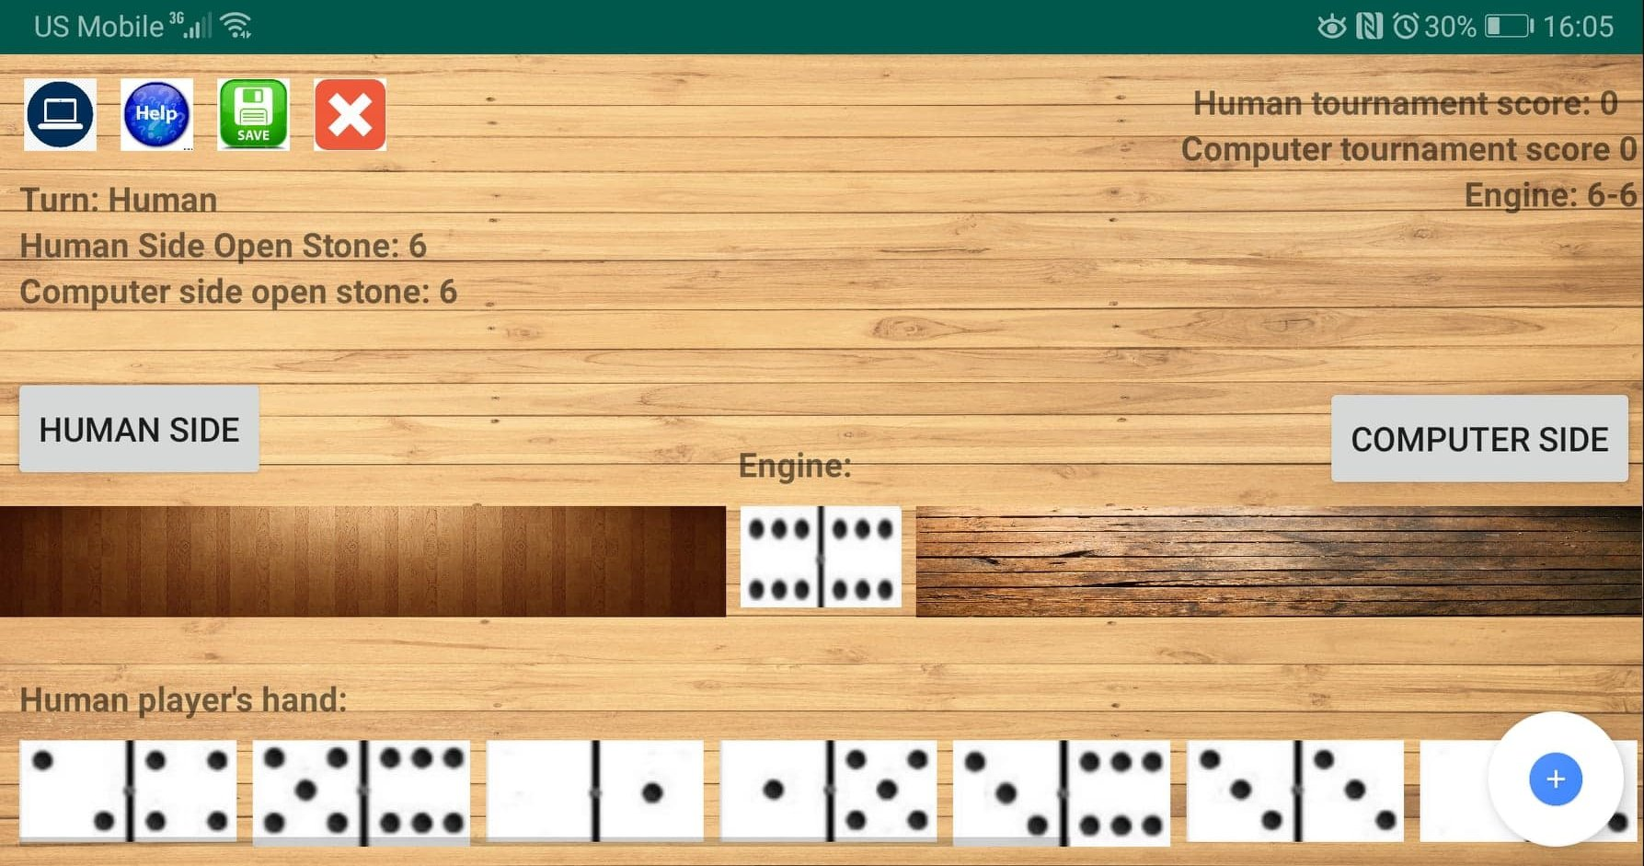

As the page indicates, it is the human player’s turn to make a move. The human player must place a tile that has at least one stone whose value equals the value of the open stone of the side he wants to place the tile on. Here, let us assume that the computer player has not passed. The human player does not have a double tile whose value equals the value of the open stone on the opponent’s side. So, the human player can only place tiles on his side. The human player can choose to place either 5-6 or 3-6 tile because those tiles have at least one stone whose value equals to the open stone on the human side. The human player should touch the tile he wants to play from his hand. After doing so, he should select the side he wants to place the selected tile on by touching the button on the left side labeled “HUMAN SIDE.” After pressing the button, he should press the floating action button (the button with plus symbol inside blue circle) on the bottom right corner of the screen. Upon pressing the button, menu options will appear above the floating action button as seen in the picture below.

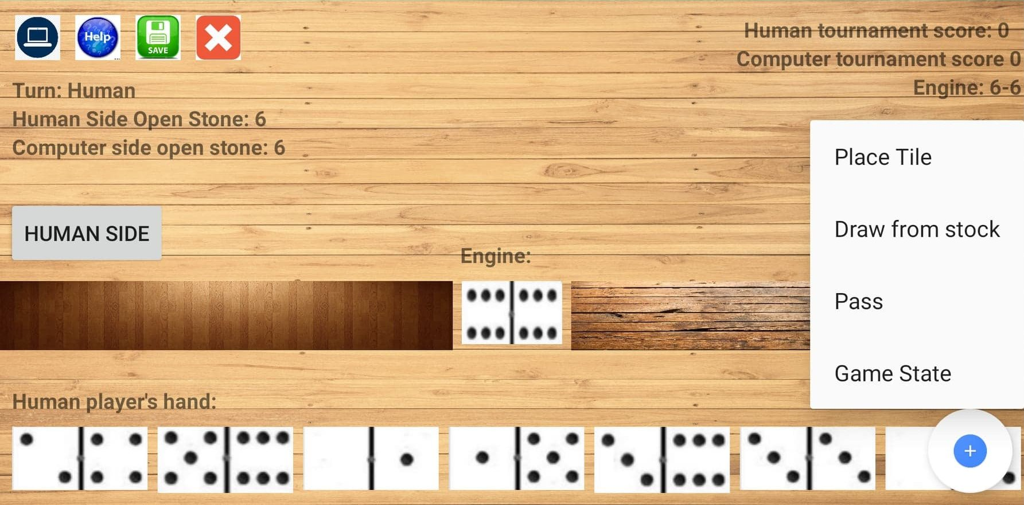

In order to successfully place the tile, the human player should now touch “Place Tile” option to complete his move.

The player must place a tile if he has a valid tile he can place on one of the sides. If the player finds it difficult to make a move, he can click the “Help” icon at the top left section of the image. Touching the “Help” button will show a text that contains instructions on making an efficient move.

If the player cannot place a tile legitimately on the table, he should draw one tile from the stock if the stock is not empty. If he can place the newly drawn tile on the table, he should place the tile by using the procedures described earlier. If he cannot legitimately place the drawn tile, he should pass.

It is relatively simpler to draw a tile from the stock and to pass. The user neither needs to click any tile nor any side button to execute these moves. He can simply click the floating action button and choose the desired option.

If it is the computer player’s turn to make a move, the human player needs to press a Computer icon on the top left corner of the screen. Once the user presses the button, the computer will makes its move automatically and move summary of the player’s move will be shown.

The user can press the floating action button and select the “Game State” button for testing purposes. This is practically cheating if you are merely a player. However, I included this feature so that my professor can verify the validity of the game if need be. “Game State” option will display both players’ hands and the tiles yet to be drawn from the stock.

“Game State” looks like this:

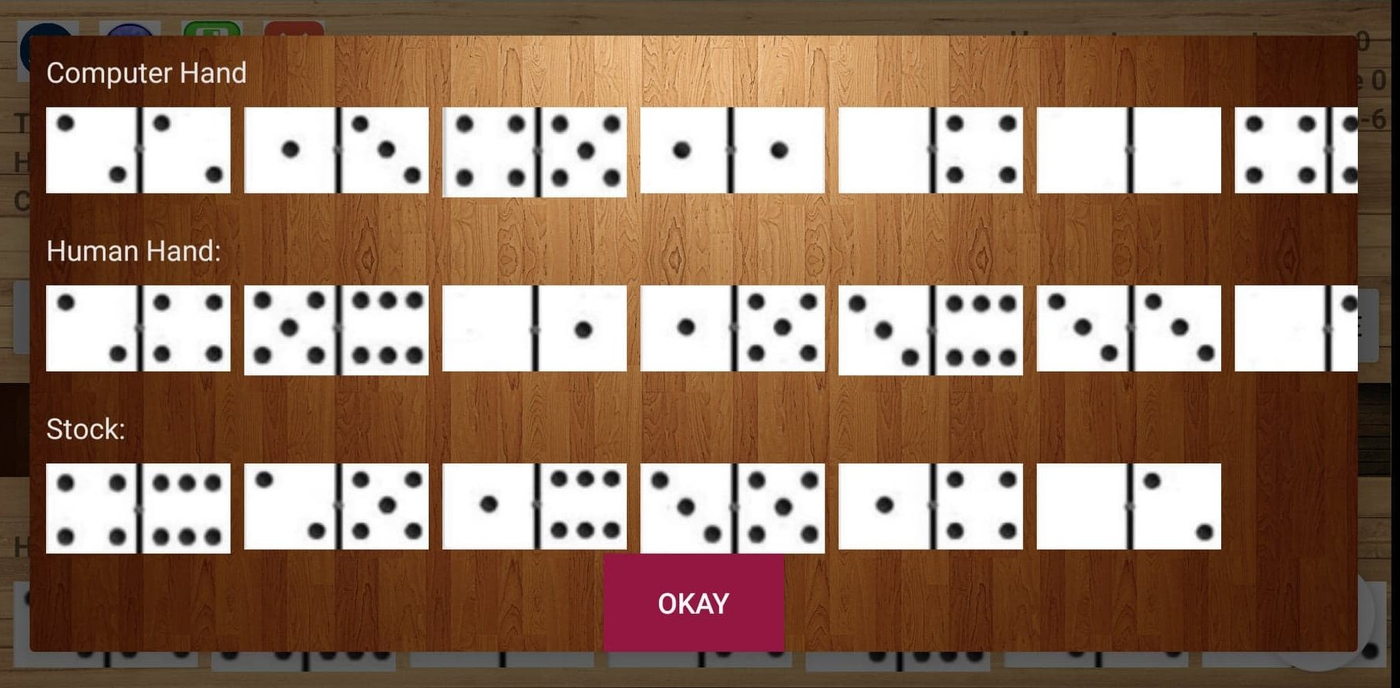

The views for computer hand, human hand and the stock are scrollable.

**4) DESIGN**

**a) Discussion of the major aspects of the game**

**i) Save Game/ Load Game**

Saving a game at any time and loading a saved game are some of the features that makes this game interesting. I implemented saving and loading game using tools offered by the Java language and the Android studio platform.

For instance, to save a file, I make a file ready for saving in the user device’s home directory using the following two lines:

String fileName = **"savedGame.txt"**;

fileName = Environment.*getExternalStorageDirectory*().getAbsolutePath() + **"/"** + fileName;

Then I initialize a formatter object with the “fileName” and use the formatter object to write to the file.

To load a file, I do something similar. I make a file ready for loading using the following lines of code.

**final** String fileDir = Environment.*getExternalStorageDirectory*().getAbsolutePath();

fileName = fileDir + **"/"** + fileName;

Then after verifying if the file exists, I initialize a Scanner object with the “fileName” and then I use the scanner object to read from the file.

* **Save Game** - When the user presses the save icon in the main game screen, methods in the Round class save the key details of the game like the tournament threshold score, the round number, the engine tile, the tiles on the table, the tiles in players’ hands, the tiles yet to be drawn from the stock, players’ tournament scores, the player playing next and if the previous player passed on his turn. The game details are saved into a text file called “savedGame.txt” The file will be saved in the home directory of the user’s phone. If the user wants to access this file, the user needs to do the following things.
  + The user needs to give storage permissions to the Cubaminoes application. In order to do this, the user needs to go to Settings and the Apps/ Applications. After that, the user needs to select “Permissions.” Then, the user needs to search for the Cubaminoes app and click on the icon. Then, the user needs to toggle the Storage icon if storage access is already not provided.
  + If Cubaminoes has storage permission on the user’s device, the user needs to connect his device to a computer using a USB cable.
  + Then, on the user’s device, the user will be prompted with options on his device. The user will be asked if he wants to use USB to transfer photos, transfer files or charge only.
  + The user should select “Transfer files” option.
  + If on a windows computer, the user needs to go to My Computer. If on a linux/ max device the user needs to go to the File Explorer window. Then, the user needs to select the drive for his device.
  + Then the user will be able to see a file called “savedGame.txt” . That file may give the idea of the format in which the application saves the game state.
* **LoadGame** - In order to load a game, the user needs to select the “Load Game” button in the home page of the application (as soon as the application opens). The program will prompt the user to enter the name of the saved file from which the program needs to load. If the user wants to load the recently saved game, he needs to select “savedFile.txt” in the text box. Then, the program will load a previously saved game.

A picture of the home page with load game feature is displayed below:

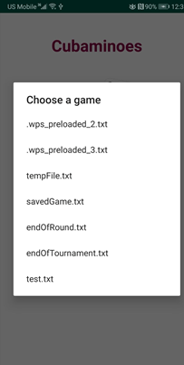

The beautiful thing about this feature is that the user does not need to always select “savedGame.txt” This was especially helpful for me to test the application. I wrote customized test files that had format similar to the savedGame.txt file. Then, I used the program to load those files. The files I loaded were specifically written so that one or more aspects of the game could be tested. To learn more about how I used these test files, take a look at the section titled “Test Plan and Test Results.”

**ii) Computer’s Strategy**

The computer needs to decide the following things:

* What type of move to make: During this turn, a player can either place a tile, draw a tile from the stock if he can or pass. Whenever the computer can legitimately place a tile on the table, the computer’s move option is always to place a tile. This makes sense for two reasons. First, it is in accordance with the rule of the game. If a player as a tile he can legitimately place a side of the table, he must do so. He cannot choose to draw more tile or pass if he can place a tile. Second, it makes sense to place as many tiles on the table as possible. That is because a player can win the game if he empties his hand first. A player can also win the game if the sum of numeric value of tiles in his hand is less than the sum of numeric value of tiles in the opponent’s hand. If the player has fewer tiles, the sum of tiles is likely to be less.

If the computer player cannot legitimately place a tile on either side of the table, it tries to draw one tile from the stock. If the stock is not empty, the player can do so. If the computer player can legitimately place the newly drawn tile on either side of the table, it will do so. Else, it will pass.

In a turn, a player cannot draw more than one tile from the stock. If the player cannot place a tile and the player cannot draw additional tile from the stock, the player must pass. So, the computer player will choose to pass if it cannot place a tile or draw a tile from the stock

* What tile to place on the table: The computer player will choose to place a tile that has at least one stone whose value equals to the value of the open stone of the side he can place a tile on. If the computer player has more than one tile he can legitimately place on the table, it will choose to place the tile that has the highest numeric value. This makes sense because at the end of the game, a player can win the game if the sum of numeric value of tiles in his hand is less than the sum of numeric value of tiles in the opponent’s hand
* What side to place the tile on: If the computer player has a double tile in his hand, it will choose to place the tile on the opponent’s side. There might be only few chances to place a tile on the opponent’s side and it makes sense for the computer placeyer to place a tile on the opponent’s side especially it the player has a tile that he can place on his side in his next turn.

If the computer player does not have any double tile in its hand, it will try to place a tile on its own side. Although a player is able to place a tile on their opponent’s side if their opponent has passed, it still makes sense to place a non double tile on the player’s own side. The opponent passed because he does not have a tile in his hand that has a stone that matches the value of the open stone on his side. In other words, he is blocked. We want that to continue because if a player gets blocked, he cannot place a tile on the table. We do not want the block to open by placing a tile on the opponent’s side. For instance, let us assume that the open stone on the opponent’s side is 5. The opponent will pass if he does not have a tile that has stone with value 5 in his hand. Say, we decided to place a 5-4 tile on the opponent’s side. If the opponent has a tile that has stoe with value 4, the opponent can make a move. The block is gone. This is undesirable because we want the opponent to suffer.

If the player does not have a double tile and cannot place a non-double tile on his side, then the player should try to place a tile on the opponent’s side. The player can do so if the opponent passed in their previous turn. The computer player does exactly that.

All of the strategies discussed above are Computer’s strategy but the strategies are not implemented in the Computer class. The strategies are implemented in the Player class. This is because the human player also needs to use exactly the same strategy the computer player uses to get help. Because the strategies are written in the Player class, both its children can use the strategies.

**iii) Help feature**

Help feature is only available when the human player is making moves. If the user asks for help when it is the computer player’s turn to make a move, an empty string will be displayed. However, if the human player asks for help when it is the human’s turn to make a move, the program will provide detailed instructions on the type of move the player should make.

If the program suggests the player to place a tile on the table, it will also suggest the exact tile and the side the player should choose to place the tile on. Regardless of the type of action the Help feature suggests, it will display a rationale for why certain move should be made. A picture of the human player using the help feature is displayed below:

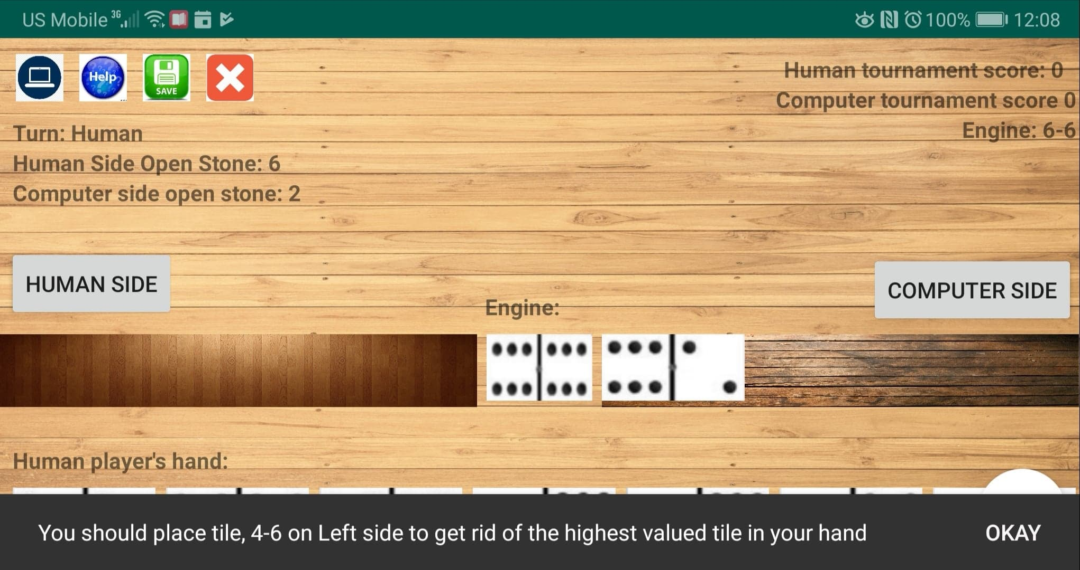

**b) Description of classes used in the project**

There are twelve Java classes used to implement the game. Nine of those classes are model classes while the three of those classes are view classes. One of those classes, GameActivity acts both like the Controller class and the View class.

As the name suggests, the view classes control the view of the game (what the user can see). The view class reference to the model classes but the model classes do not have any reference to the view classes. The model classes, on the other hand, handle the game logic. All game state is saved in the model only, not in the view. The view updates itself based on the model. The controller refreshes the view when necessary.

The classes are listed below:

**i) Model classes**

- Tile - This is the most fundamental class of the entire program. A tile is a synonym for domino. It has two member variables, m_leftStone and m_rightStone. The two member variables represent the left and the right stone of the tile. The stones can only have values ranging from 0-6.

- Stock - A stock contains many tiles. The class is responsible for drawing the next tile from the collection of tiles and return it to the caller so that the tile can be distributed. It is responsible for shuffling the tiles and storing them.

- Side - This class can contain tiles. This makes sense because in the game, the players are supposed to place tiles on one of the sides. The Side class also has a member variable, m_openStone that denotes the open stone for the side. The players are supposed to place tiles according to the open stone.

- Table - A table has two sides, the right side and the left side.

- UserInput - The user needs to choose what type of move he wants to make. If the user wants to place tile on the table, they need to select the tile and the side they want to place the tile on. These information are stored in UserInput class.

- Player - The class stores information about the things a player should have in the game. A Player should have a UserInput, hand (collection of tiles) and score. The class provides functionality to update the score. It also provides ways to add and remove tile from the hand. Player class is an abstract class. So, it can not be instantiated. The class makes polymorphic behavior possible. Human and computer players make moves in different ways. For instance, the human user clicks on the tile and the side he wants to place his tile on. The computer does not do that. Although both human and computer players make move, they make move in unique ways. So, some functions are abstract and are implemented by the classes that derive from the player class.

- Human - Human class derives from the Player class. So, it has access to all the

protected member variables of the Player class like the hand, the score among other things.

- Computer - Computer class derives from the Player class. So, it has access to all the

protected member variables of the Player class like the hand, the score among other things. The class has methods that make automatic move selection possible.

- Round - A round is a part of a game (the entire tournament). The round class contains references to a table, a stock, the human player and the computer player. This class is like the heartbeat of the program because it contains methods that execute and verify the moves that players make. The class is responsible in implementing logic of most features of the game including computing and placing engine, saving the game, computing scores of players and enforcing general game logic.

- Tournament - Tournament is a collection of one or more rounds. The class contains functions to load the game from a text file. It also contains methods to parse information from a text file to make the game loadable.

**ii) View classes**

- IntroPageActivity - This class deals manages the view of the application’s home page. When the user presses, “Load Game” button in the home page, the user is prompted to enter a file name. When the user enters the name of the file in which game data has been stored, one of the methods in the IntroPageActivity class initializes a new tournament object and loads the game.

When the user presses “New Game” button in the home page, the user is prompted to enter a “max tournament score.” This is the threshold tournament score. If a player gets points equal to or greater than the threshold tournament score, the tournament is over. After the user enters a valid tournament score, one of the methods of the IntroPageActivity class initializes a tournament object and a new tournament starts. A screenshot of the view IntroPageActivity class manages is displayed below:

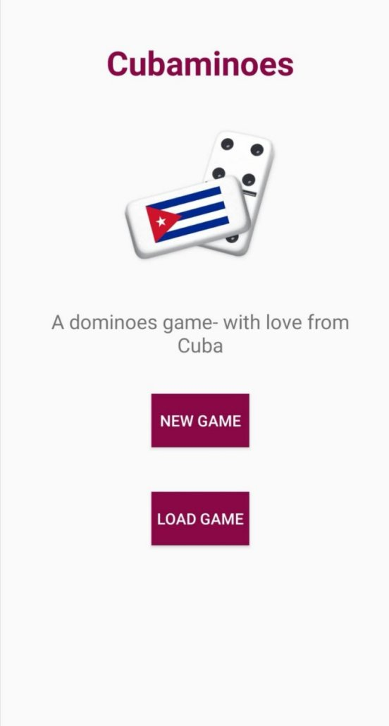

- GameActivity - activity_game.xml is the primary view of the application. GameActivity is the class that manages the activity_game.xml ‘s layout view. This class includes methods that respond when certain buttons are pressed. The class also includes methods that add new widgets to the existing layouts. This class acts as the link between the model classes and the view classes. At times, although primarily a view class, at times, the class acts like a Controller, refreshing the view when necessary.

- GameOverActivity - This class shows view that contains text boxes that display tournament statistics like the players’ score at the end of the tournament and the tournament winner.

**c) User Interaction Flow**

This section describes the user interaction flow of the program. At the start of the game, users are first shown a “Home Page.” Home page will will have two buttons the users can click, a button labeled “New Game” and a button labeled “Load Game.” When the user cicks either of those options, a dialog box will pop up that prompts the users for more information. Please read section 4.b.ii) for a detailed description of the dialog boxes and the “Home Page” in general.

After the user has entered appropriate information, they will be directed to the main game screen. Once the game is over, the user will taken to a screen that has a summary of the tournament statistics. For more detailed description of these screens, please read section 4.b.ii.

In the main game page, the page where the user will spend most time on, three dialog boxes may appear. The first dialog box pops up when the user clicks the “Game State” option after clicking the floating action button on the bottom right corner of the screen. The second dialog box will appear after each round is over. The other dialog boxes appears at the start of each round where the user will be prompted to click a button. The dialog box will not disappear until the user presses the button the program asks for.

The following images five a detailed description of each interaction components in the application.



 Home page 

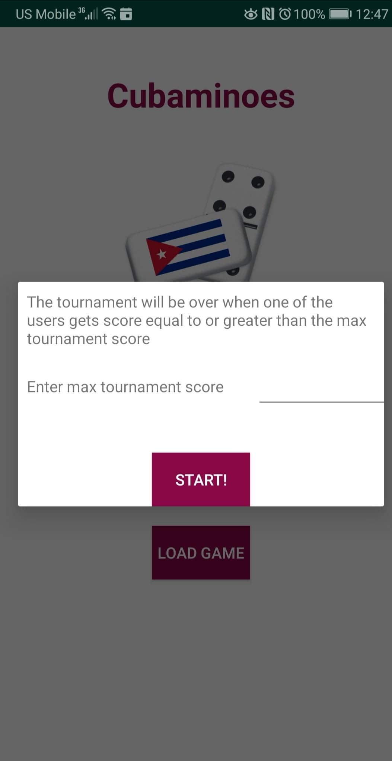 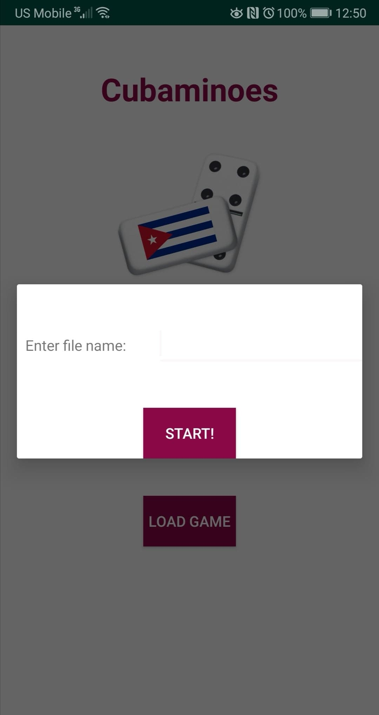

Home page “New Game” dialog Home page “Load Game” dialog

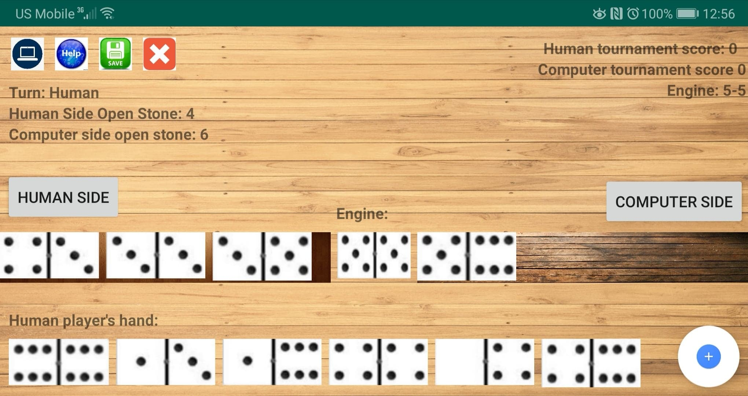

Main Game page (activity_game.xml)

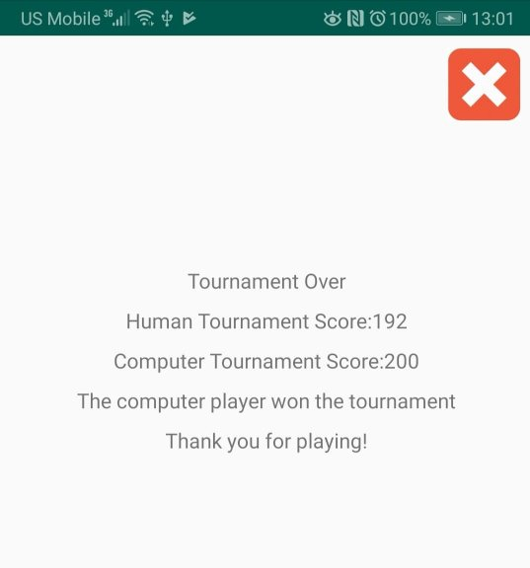

Final Game Page (activity_game_over.xml)

**d) Data Structures used in the application**

At many points in the application code, I have used auto-resizable lists. java.util provides a structure called ArrayList that serves this purpose. For instance, the Side class has an ArrayList object as its member variable. Because the number of tiles that can be added to a Side at a time is not fixed, it makes sense to use an auto-resizable list like ArrayList. Using an ArrayList also allowed me to use features offered by the Collections class like shuffling and reversing the list.

**e) File structures used in the program**

Here is the project directory tree that gives an idea about the file structure used in the project.

AndroidManifest.xml

java

└── edu

└── ramapo

└── aghimir1

└── cubaminoes

├── Computer

├── GameActivity

├── GameOverActivity

├── Human

├── IntroPageActivity

├── Player

├── Round

├── Side

├── Stock

├── Table

├── Tile

├── Tournament

├── UserInput

res

├── drawable

├── layout

├──activity_game.xml

├──activity_game_over.xml

├──activity_intro_page.xml

├──activity_end_of_round.xml

├──layout_file_name.xml

├──layout_game_stats.xml

├──layout_place_engine.xml

├──layout_tournament_score.xml

├── menu

├──popup_menu.xml

├── mipmap

├──ic_launcher

├──ic_launcher_round

├── values

├──colors.xml

├──strings.xml

├──styles.xml

**5) TEST PLAN AND TEST RESULTS**

When designing a software, it is important to have a good testing approach. When I am writing a large piece of software, I usually follow Design, Implement and Test approach. I start by designing a small segment of the program, perhaps a class. Then, I implement my design. As soon as I implement a function, I test the function. Professor Amruth Kumar once told us that writing 20 lines of code and making sure that the code works is a lot better than writing 200 lines of code that does not work. I fully abide by that philosophy.

Whenever I implemented a class, I made sure that each and every function in the class was doing what it was supposed to do. The best thing about using Java is that each class can have its own main method. Android Studio enabled me to run each class and test it separately. I used main methods in the classes to test the features of the classes. My bottom-up coding approach, combined with this style of testing, enabled me to make sure that the small functions and classes were robust before I started working on the larger classes.

Before jumping into working with User Interface, I designed a text-based game first. Even before I completed a working Human vs Computer game, I started by implementing a Human vs Human two-player game. Designing a Human vs Computer game would take me a lot of time as designing strategies for the computer player is tough and time-consuming. That meant, I could not test critical functions in the Round class like distributing tiles, creating and forming engines and making sure that the game would properly for two players. Once I had created a working Human vs Human game, I designed strategies for the Computer player and made a working Human vs Computer text-based game. I made sure that the game enabled the players to make moves, check the validity of the moves, made sure that the scores were being updated, the round was ending and the new round was starting. I started working on a Graphical User Interface (GUI) based game relatively late because I was confident that once my model classes were working, integrating them with view classes would not be very difficult, especially because I had prior experience with Android programming.

Although I tested all components of the game before I starting working with Graphical User Interface, at times, testing was difficult. For instance, if I wanted to test if the program was updating the players’ tournament scores after each round ended, I had to play the entire round from beginning before I could test what I wanted to test. This process was extremely tedious. Therefore, I had to think of a better testing approach.

I decided to implement my own Serialization functionality into the “Load Game” component of the game. The Tournament class parsed relevant information from a text file like the tournament score, the round number, the engine, the tiles on the table, the tiles on the Human and the Computer player’s hand, the players’ tournament scores, the next player and whether the previous player passed in his turn. By parsing these data, my program was able to create a game state. This state then could be used to continue the game.

So, if I wanted to test if the necessary updates to the players’ hands, the table, the stock, the round number and the engine tile were being made when a round was over, I could simply use a text file in a format that the program could read to load a game state. This could enable me to continue a game from the point recorded in the game state instead of going through an entire round to test end of a round. I have included the format of a text file I used to test if a round was ending properly.

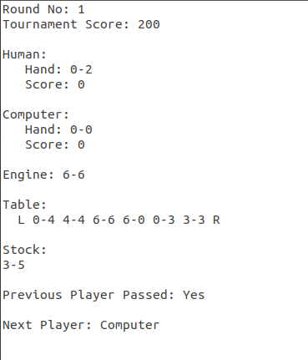

Since the previous player passed in his turn, the next player (computer player) could place a tile on the human side as well. If the computer player placed his tile on the human player’s side and the round ended properly with scores being updated, the program passed the test. The program went through tests like these where I designed test cases and used the program’s “Load Game” feature to load files that had test cases. I tested all the features the program offers to deliver using these test cases. I know that my program does not have many bugs and does not crash because the program passed test cases like this.

Apart from testing the program myself, I also asked my friends and my parents to play the game once I finished designing it. One of my friends suggested me that I could improve the User Interface by adding a summary of moves the player made. I incorporated his suggestion into the program. Now, the program provides move summaries after each and every move. This also made me easier to figure out the exact move the players made during their turn. I also found other issues when my friends played the game. One of the issues I found was the Computer player’s strategy was not always the right strategy to play the game with. I will use the image below to illustrate my point

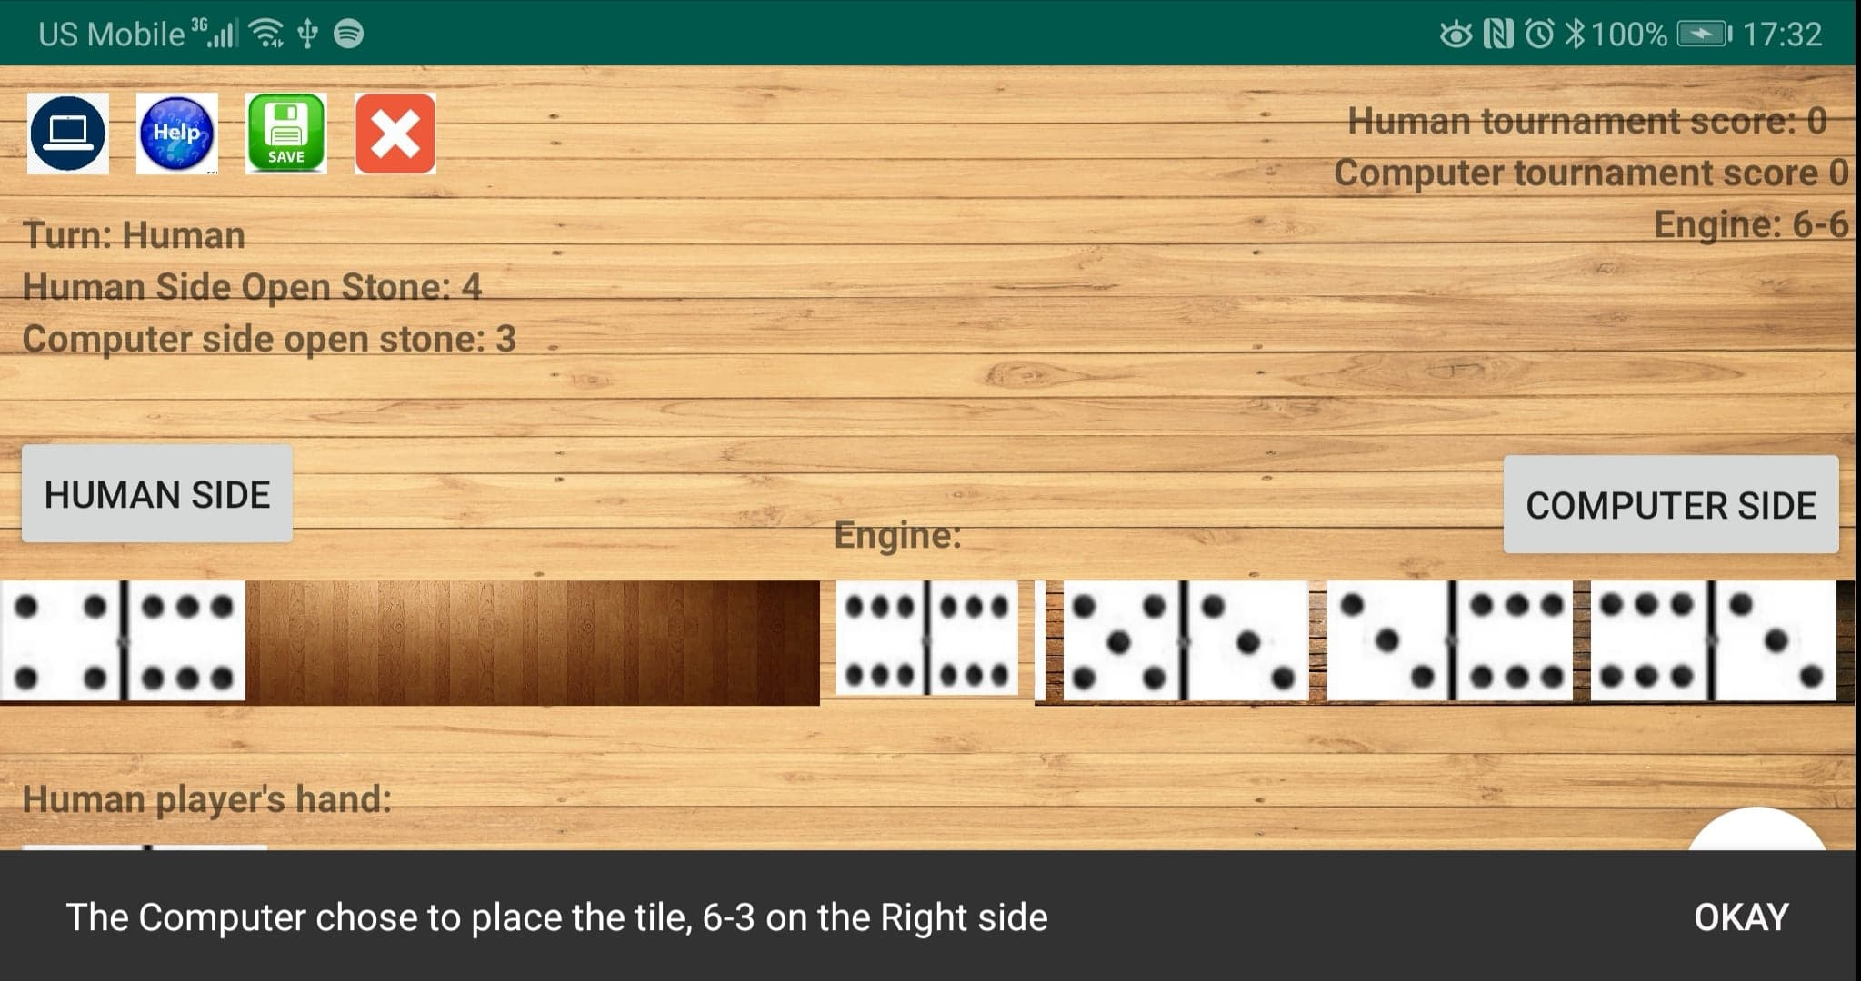

In the picture above, the open stone on the Computer’s side is 6. The human player does not have any valid tiles to place on the table. Let us assume that the computer player has 1-1, 6-3 and 6-1 on his hand. The computer player chose to play 6-3 instead of playing 6-1.

Although in the short run, the computer’s choice makes sense because one of the objectives of the game is to get rid of the highest valued tiles in your hand. The computer does this. But, this is not necessarily the optimal decision in the long run. Had the computer player played 6-1, the computer player could play 1-1 in his next turn, thereby getting rid of more tiles. So, the Computer’s strategy did not prove sophisticated enough to keep this into account.

**6) SUMMARY AND CONCLUSIONS**

This project was a good learning experience for me. Working on this project made me very comfortable with object oriented programming and event driven programming. I also learned how to design a good user interface and about the right way to test a massive project.

At the start of the semester, my wishlist had the following items on it:

* To design a fully working human vs computer game where the computer player would make efficient moves by itself
* To implement help feature for the Human player so that they could play the game using computer player’s strategy
* To design the game in such a way that a human player could play against another human player over a Bluetooth connection

I was able to implement the top two items on my wishlist. Cubaminoes is a fully functional human vs computer Android game where the computer player choose its move based on the tiles in its hand, tiles on the table and game situations such as the emptiness of the stock and if the previous player passed on his turn. The computer player, based on the game conditions mentioned above, chooses the right move using an algorithm discussed in Design section (section 1.a.ii). The game also has help feature, where the program generates instructions for the human player to make efficient moves using the same strategy the computer player uses.

I was not able to implement the last item on my wishlist because I did not have enough time to implement it. Although a semester is a long time for someone to work on a project, having to work on this project from scratch amidst the pressure of the job search process and other courses, made it appear like a short amount to work on a massive project like Cubaminoes.

As expected, I faced some challenges along the way. One of the primary challenges was to implement the “Load Game” feature using my own methods and text-parsing logic. Parsing the text file to extract the necessary information was not a difficult job as Java offers excellent tools that support RegEx which make it easier to work with and manipulate strings. The difficult job was to integrate the parsed data into the game design such that the program would be able to load a game instance using the parsed data. This took a lot of effort but it was important to implement this functionality.

Implementing this feature would enable to test components of the program by using custom test files that the program could load. It would make my testing less tedious, faster and more accurate. I eventually overcame this challenge. Solving this challenge made me more comfortable with text parsing in Java. It also made me familiar with working with text files within the Android Studio platform. It also help me come up with smart testing approaches that would save the programmer a lot of time.

Coming up with strategy for the computer player was another challenge for me. I had not taken any courses on Artificial Intelligence. So, I had to search online for algorithms that I could use in my project. In the end, I came up with my own algorithm that is like a subdued version of Best-First search. It was exciting to be able to implement the algorithm such that the computer player could make legitimate moves.

Since I do not consider myself to be artistically blessed, I did not have an easy time designing user interface. My priority was to develop a functional game first. After I designed a fully working game, I started polishing my user interface design. My goal was to create a user interface that is intuitive for the user. Therefore, I added informative text boxes that made it easier for the user making a move. I also wanted to design an aesthetically pleasing user interface. I asked my friends for suggestions on how to improve my user interface. I incorporated some of their suggestions, which made my user interface visually appealing. Overall, I believe that my user interface is intuitive for the players to play the game.

Working on Cubaminoes has been a rewarding experience for me. I have not only learned to design, implement and test a large scale project, but also document it properly. I am confident that my documentation will make it easier for a programmer to read my code. I know that it will prove important for me in the future as well. My code is easier to read because it is well documented but also because it is cleaner and readable. The length of my functions have decreased considerably and my design has improved as I have become more experienced in designing larger projects.

Bibliography

“Android Multiline Snackbar.” *Stack Overflow*, 15 July 2015, stackoverflow.com/a/31429069.

“Domino.” 3.3.3, App Holdings, 28 Oct. 2014.

<https://play.google.com/store/apps/details?id=ru.appforge.domino&hl=en_US>

Ghimire, Ashish. *GitHub*, 19 Dec. 2018, github.com/ashish-ghimire/casinoAndroid/blob/master/java/edu/ramapo/aghimir1/casino/Tournament.java.

Hopp, Ted. “HorizontalScrollView: Auto-Scroll to End When New Views Are Added?” *Stack Overflow*, 18 Jan. 2011, stackoverflow.com/a/4720563.

“How Do You Play Cuban Dominos?” *Three Guys From Miami*, 3guysfrommiami.com/domino.html?fbclid=IwAR2OFo7z381Fm4wArt8FaS7ih3IoPskbTUDetFy4w_oL8RYo8rCdoSGxiyg.

Tidwell, Ken. “Domino.” *Game Cabinet*, gamecabinet.com/rules/DominoLongana.html.

“Run Your App.” *Android*, Google, developer.android.com/training/basics/firstapp/running-app.

“Save Files on Device Storage.” *Android*, Google, developer.android.com/training/data-storage/files.

“Snackbars.” *Material Design*, material.io/develop/android/components/snackbar/.